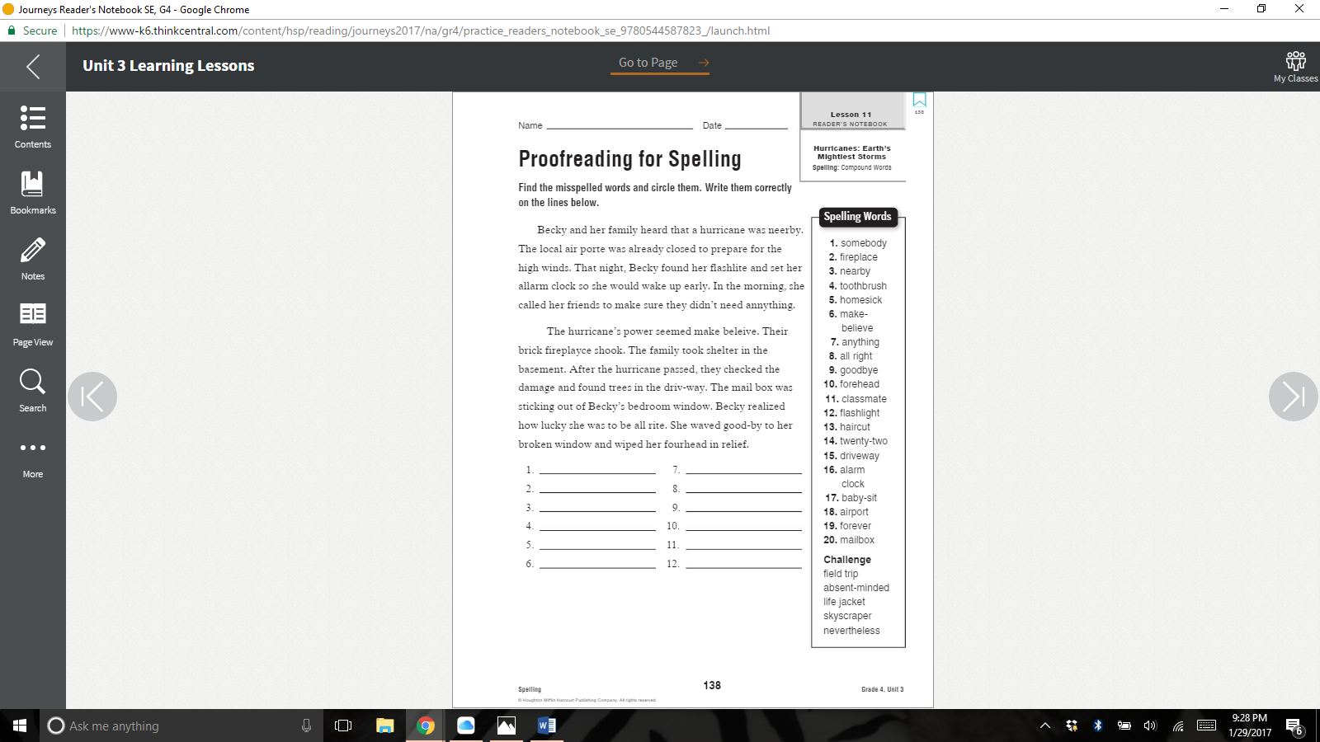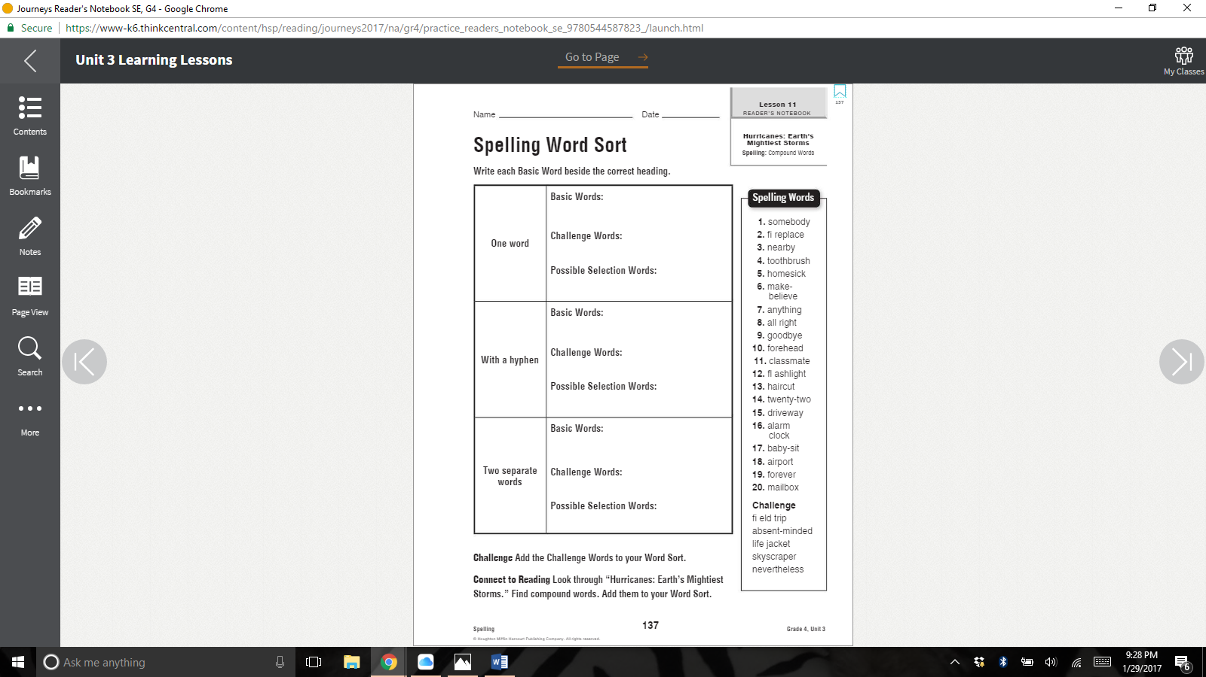

**(15)**

**(2)**

**(1+)**

**(3)**

**(1)**

**(1+)**

**(2)**

**(2)**

**(1+)**

**Week 24 Homework**

**DUE MONDAY**

**2/6/17**